1. API

* Registration

| Defect ID | DF001 |
| --- | --- |
| Tittle | User create new user without data |
| Test Cases ID | TC_Registration_02 |
| Reported Date | 7-Dec-2022 |
| Priority | High |
| Status | On Progress |
| Descriptions | When users login without fill data |
| Expected Result | - Response 400 Bad Request |
| Actual Result | - Response 200 |
| Report to | Back End |

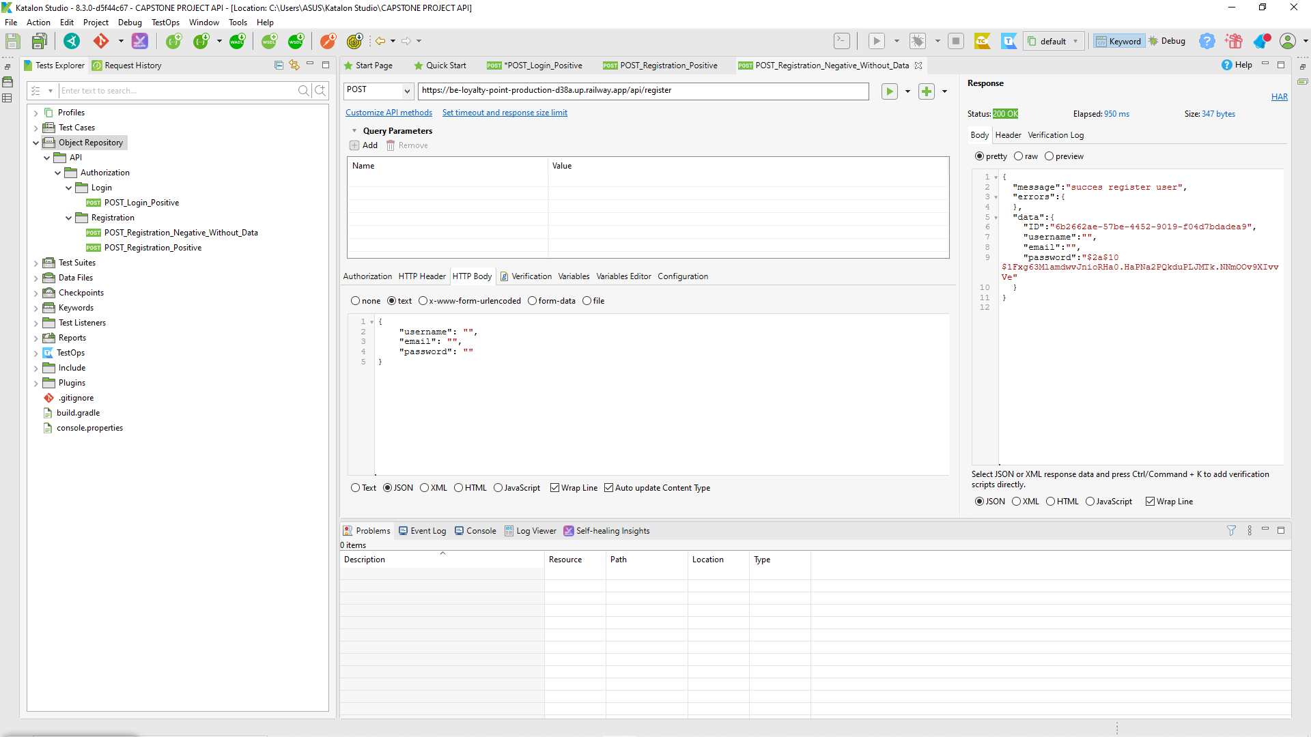

| Defect ID | DF002 |
| --- | --- |
| Tittle | User create new user without username data |
| Test Cases ID | TC_Registration_03 |
| Reported Date | 7-Dec-2022 |
| Priority | High |
| Status | On Progress |
| Descriptions | When users login without fill username data |
| Expected Result | - Response 400 Bad Request |
| Actual Result | - Response 200 |
| Report to | Back End |

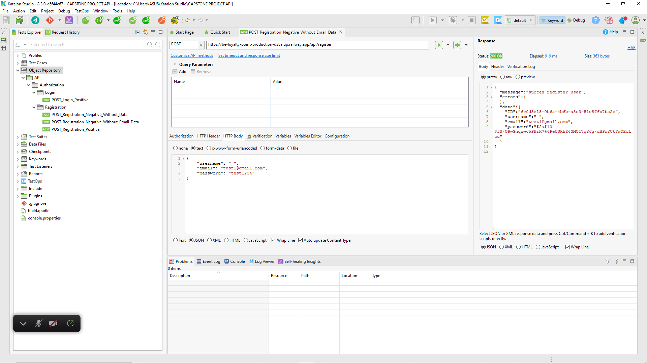

| Defect ID | DF003 |
| --- | --- |
| Tittle | User create new user without email data |
| Test Cases ID | TC_Registration_04 |
| Reported Date | 7-Dec-2022 |
| Priority | High |
| Status | On Progress |
| Descriptions | When users login without fill email data |
| Expected Result | - Response 400 Bad Request |
| Actual Result | - Response 200 |
| Report to | Back End |

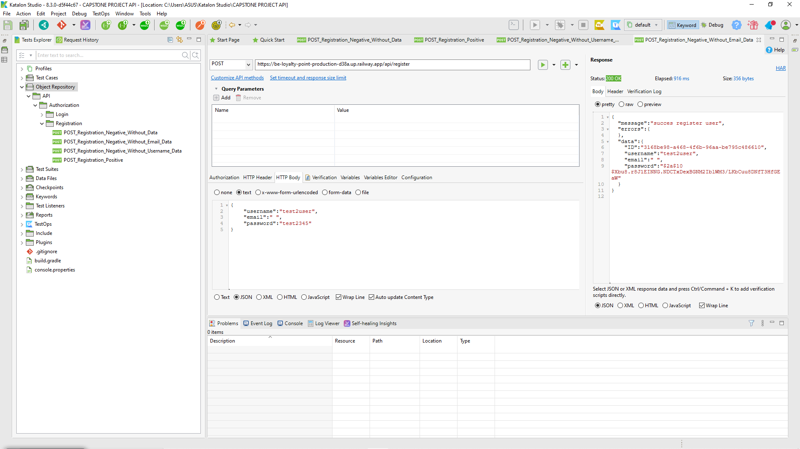

| Defect ID | DF004 |
| --- | --- |
| Tittle | User create new user without password data |
| Test Cases ID | TC_Registration_05 |
| Reported Date | 7-Dec-2022 |
| Priority | High |
| Status | On Progress |
| Descriptions | When users registration without fill password data |
| Expected Result | - Response 400 Bad Request |
| Actual Result | - Response 200 |
| Report to | Back End |

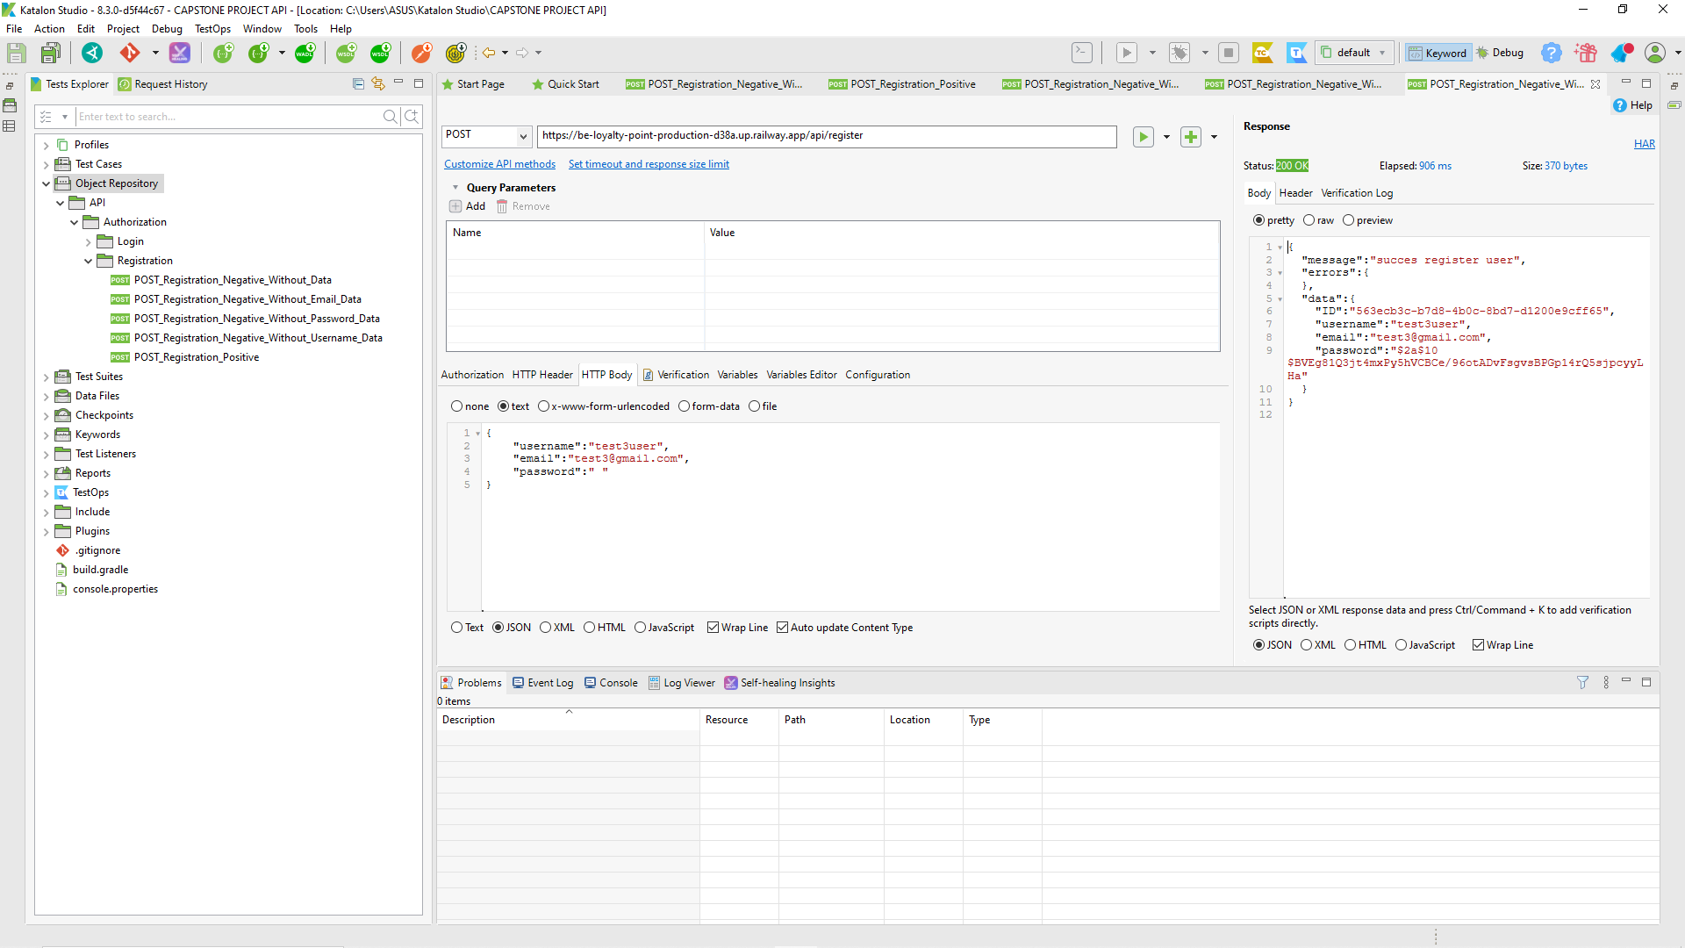

| Defect ID | DF005 |
| --- | --- |
| Tittle | User create new user with wrong fill all format form |
| Test Cases ID | TC_Registration_07 |
| Reported Date | 7-Dec-2022 |
| Priority | High |
| Status | On Progress |
| Descriptions | When users registration with wrong fill all format form |
| Expected Result | - Response 400 Bad Request |
| Actual Result | - Response 200 |
| Report to | Back End |

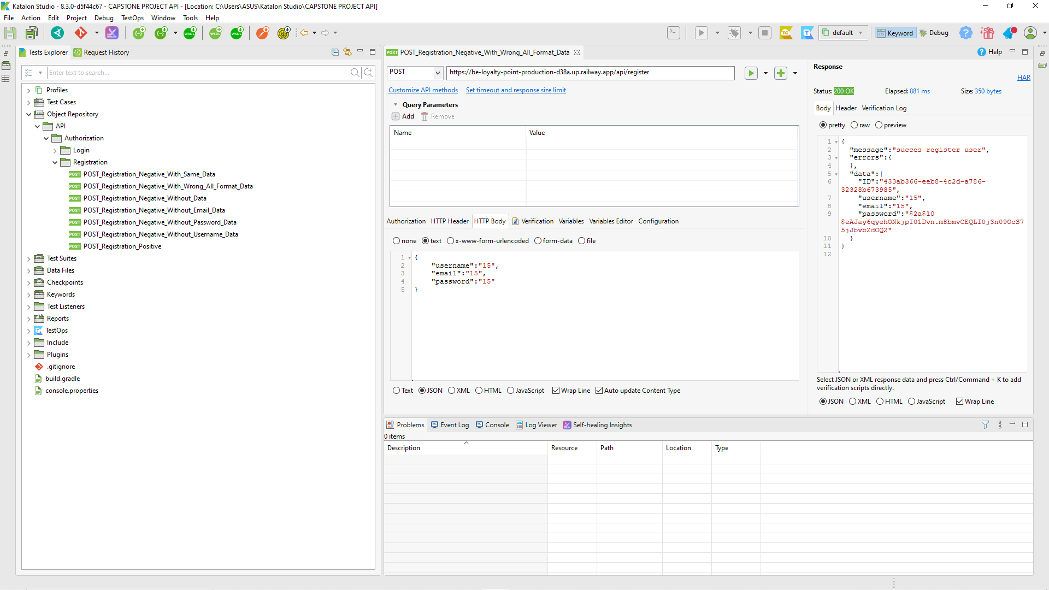

| Defect ID | DF006 |
| --- | --- |
| Tittle | User create new user with wrong fill username format form |
| Test Cases ID | TC_Registration_08 |
| Reported Date | 7-Dec-2022 |
| Priority | High |
| Status | On Progress |
| Descriptions | When users registration with wrong fill username format form |
| Expected Result | - Response 400 Bad Request |
| Actual Result | - Response 200 |
| Report to | Back End |

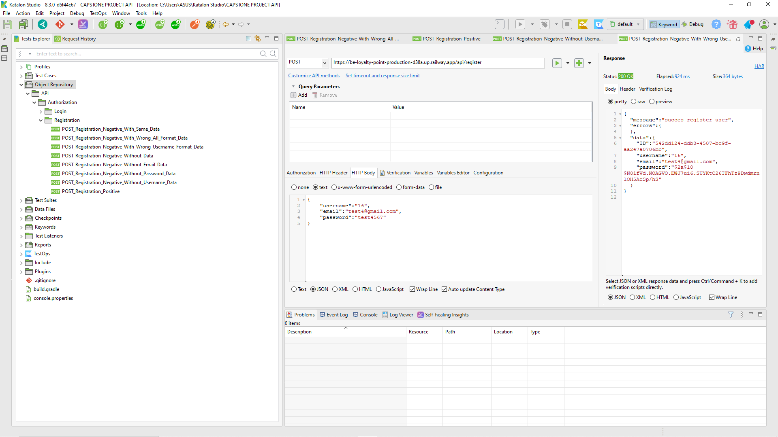

| Defect ID | DF007 |
| --- | --- |
| Tittle | User create new user with wrong fill email format form |
| Test Cases ID | TC_Registration_09 |
| Reported Date | 7-Dec-2022 |
| Priority | High |
| Status | On Progress |
| Descriptions | When users registration with wrong fill email format form |
| Expected Result | - Response 400 Bad Request |
| Actual Result | - Response 200 |
| Report to | Back End |

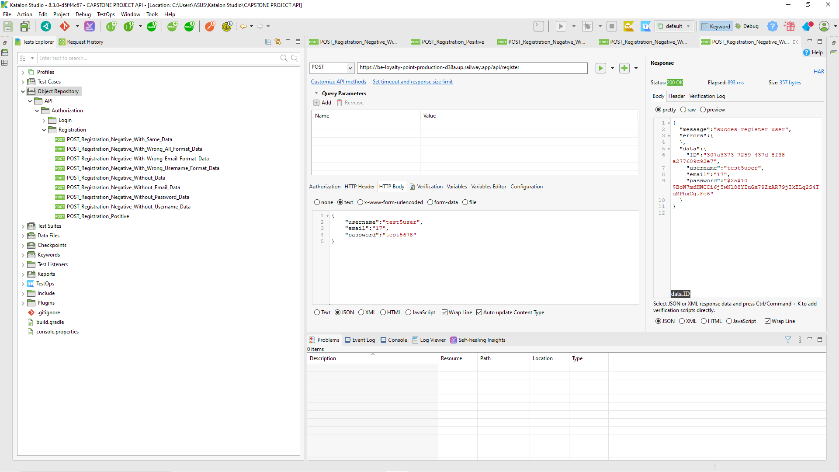

| Defect ID | DF008 |
| --- | --- |
| Tittle | User create new user with wrong fill password format form |
| Test Cases ID | TC_Registration_10 |
| Reported Date | 7-Dec-2022 |
| Priority | High |
| Status | On Progress |
| Descriptions | When users registration with wrong fill password format form |
| Expected Result | - Response 400 Bad Request |
| Actual Result | - Response 200 |
| Report to | Back End |

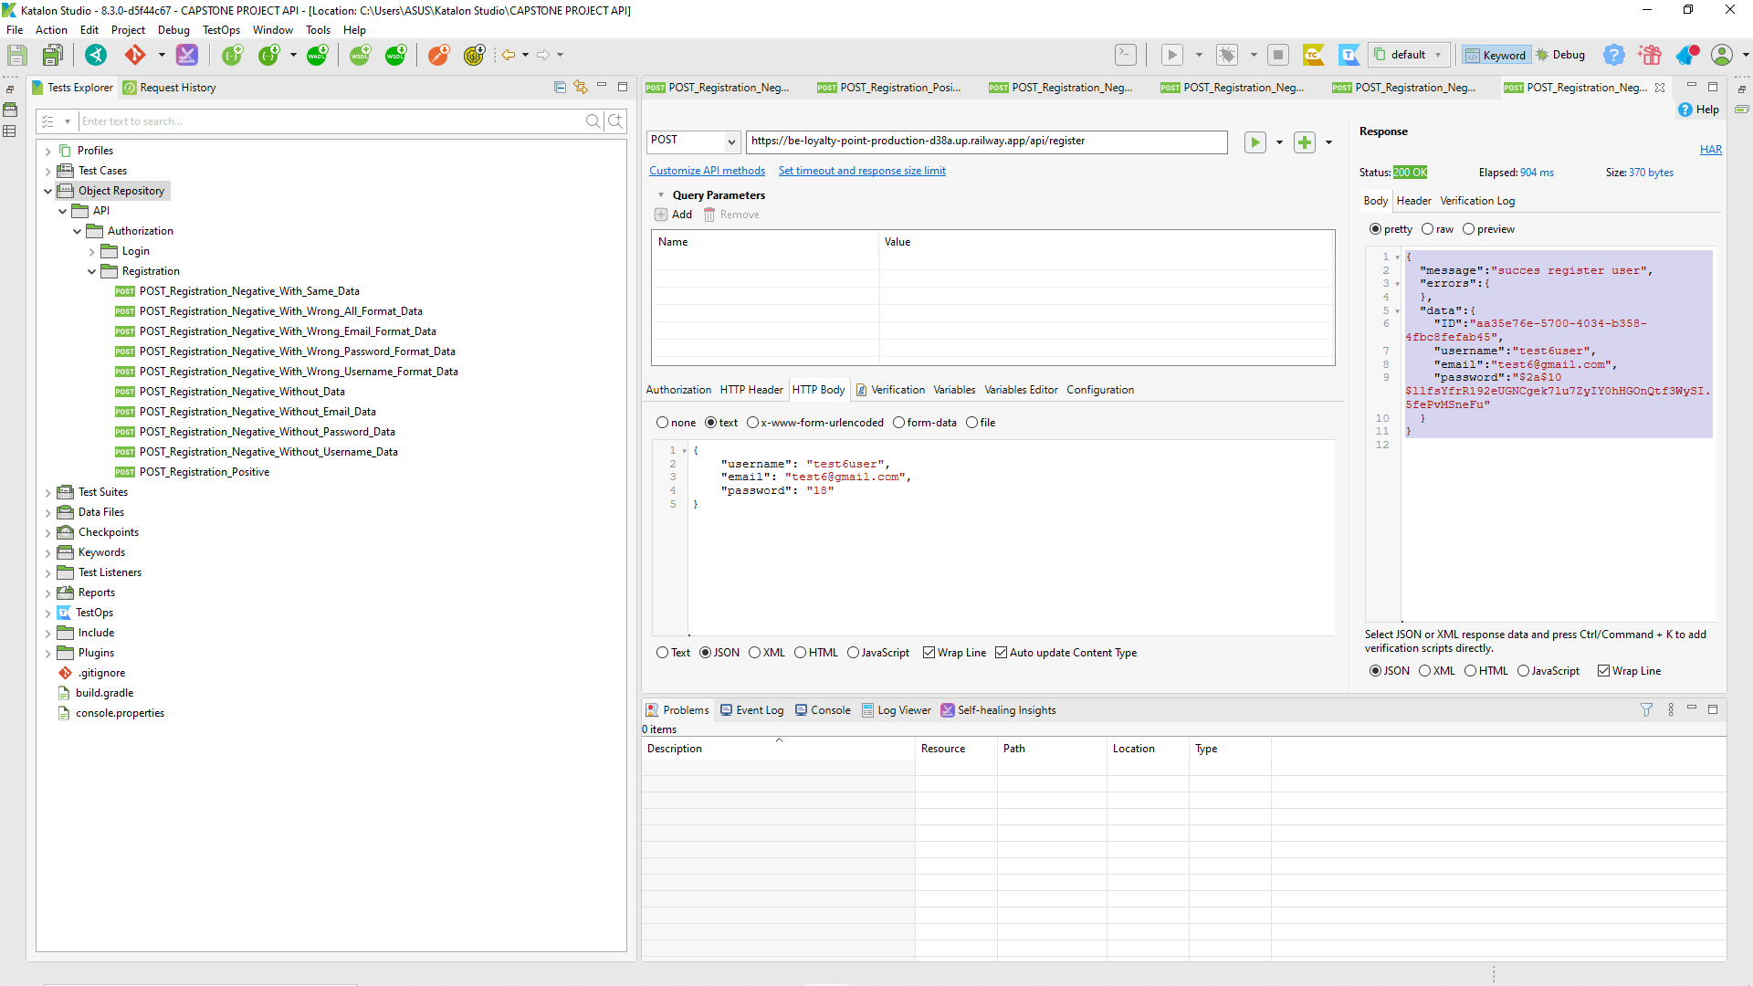

* Login

| Defect ID | DF009 |
| --- | --- |
| Tittle | User login without fill email and password |
| Test Cases ID | TC_Login_User_02 |
| Reported Date | 7-Dec-2022 |
| Priority | High |
| Status | On Progress |
| Descriptions | When users login without fill email and password |
| Expected Result | - Response 400 Bad Request |
| Actual Result | - Response 200 |
| Report to | Back End |

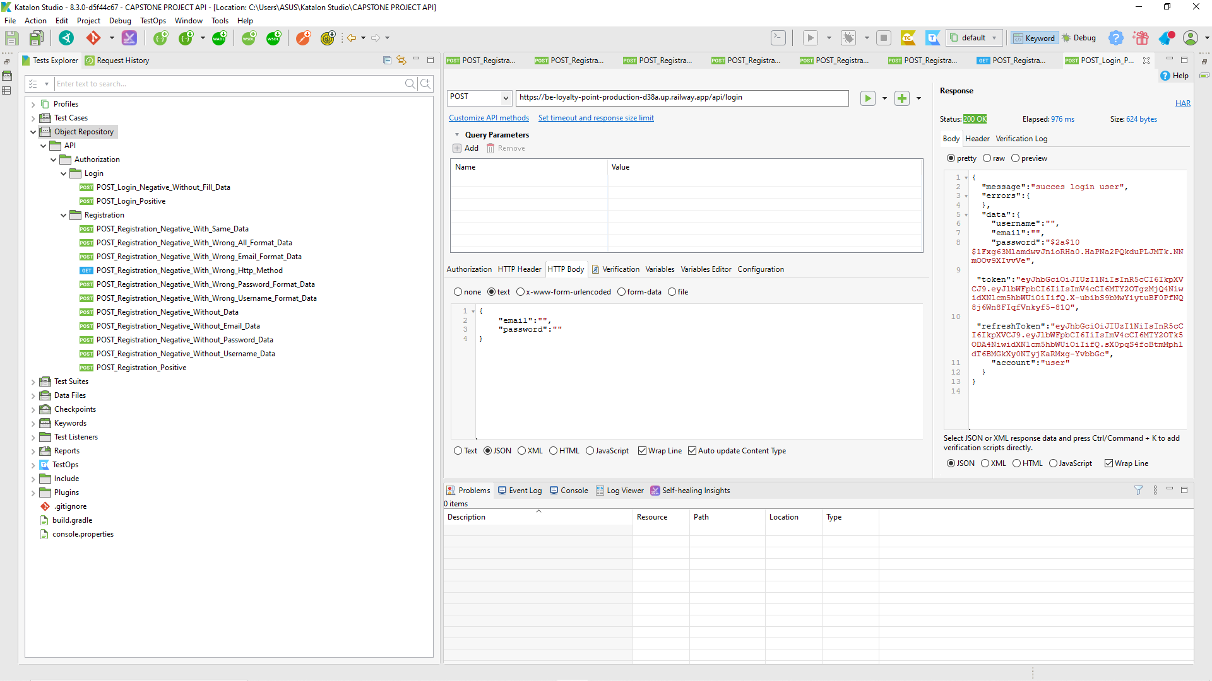

| Defect ID | DF010 |
| --- | --- |
| Tittle | User login with wrong fill all format form but already registration |
| Test Cases ID | TC_Login_User_08 |
| Reported Date | 7-Dec-2022 |
| Priority | High |
| Status | On Progress |
| Descriptions | When users login with fill all format form but already registratio |
| Expected Result | - Response 400 Bad Request |
| Actual Result | - Response 200 |
| Report to | Back End |

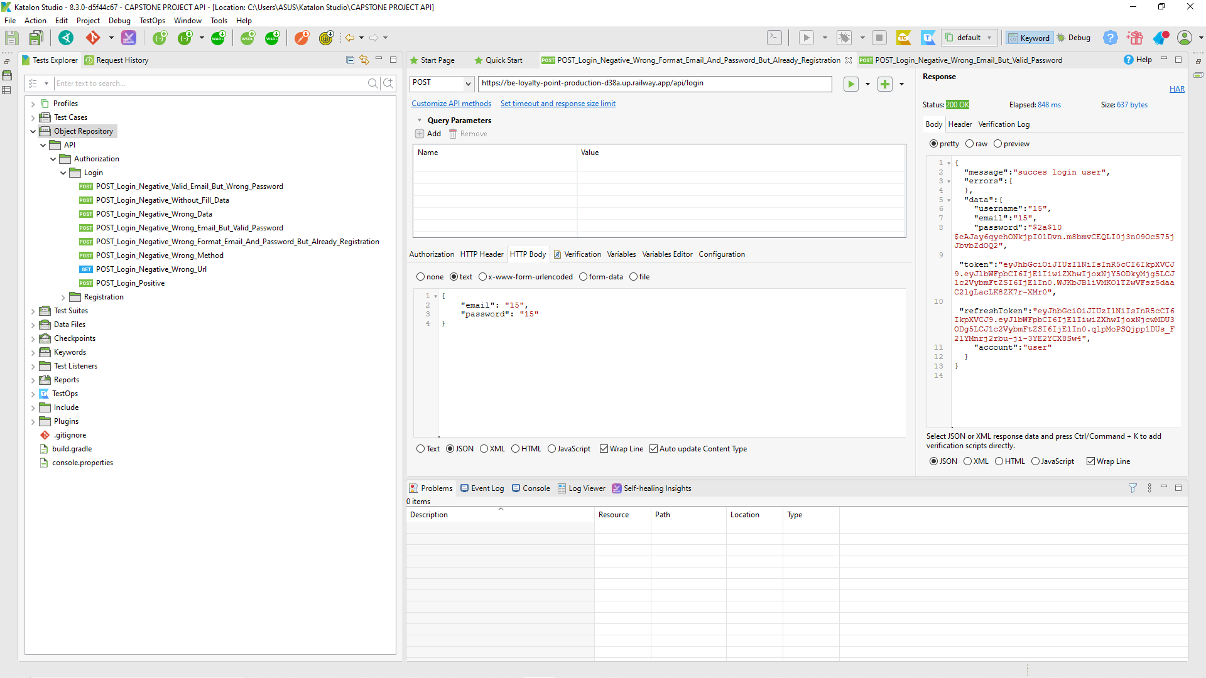

| Defect ID | DF011 |
| --- | --- |
| Tittle | Admin login without fill email and password |
| Test Cases ID | TC_Login_User_08 |
| Reported Date | 7-Dec-2022 |
| Priority | High |
| Status | On Progress |
| Descriptions | When admin login without fill fill email and password |
| Expected Result | - Response 400 Bad Request |
| Actual Result | - Response 200 |
| Report to | Back End |

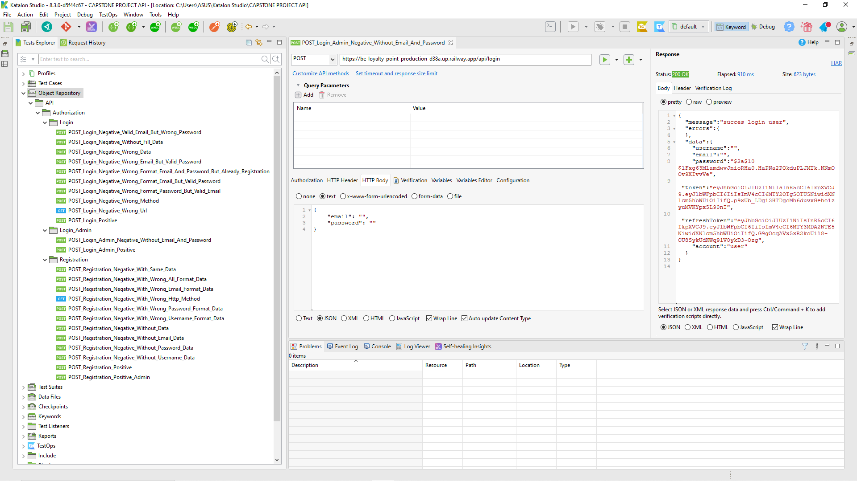

| Defect ID | DF012 |
| --- | --- |
| Tittle | Admin login without fill email and password |
| Test Cases ID | TC_Login_Admin_02 |
| Reported Date | 7-Dec-2022 |
| Priority | High |
| Status | On Progress |
| Descriptions | When admin login without fill email and password |
| Expected Result | - Response 400 Bad Request |
| Actual Result | - Response 200 |
| Report to | Back End |



* Product

| Defect ID | DF013 |
| --- | --- |
| Tittle | Admin can add new product after login as admin with same data |
| Test Cases ID | TC_Add_Product_02 |
| Reported Date | 11-Dec-2022 |
| Priority | High |
| Status | On Progress |
| Descriptions | When admin can add new product after login as admin with same data |
| Expected Result | - Response 400 Bad Request |
| Actual Result | - Response 200 |
| Report to | Back End |

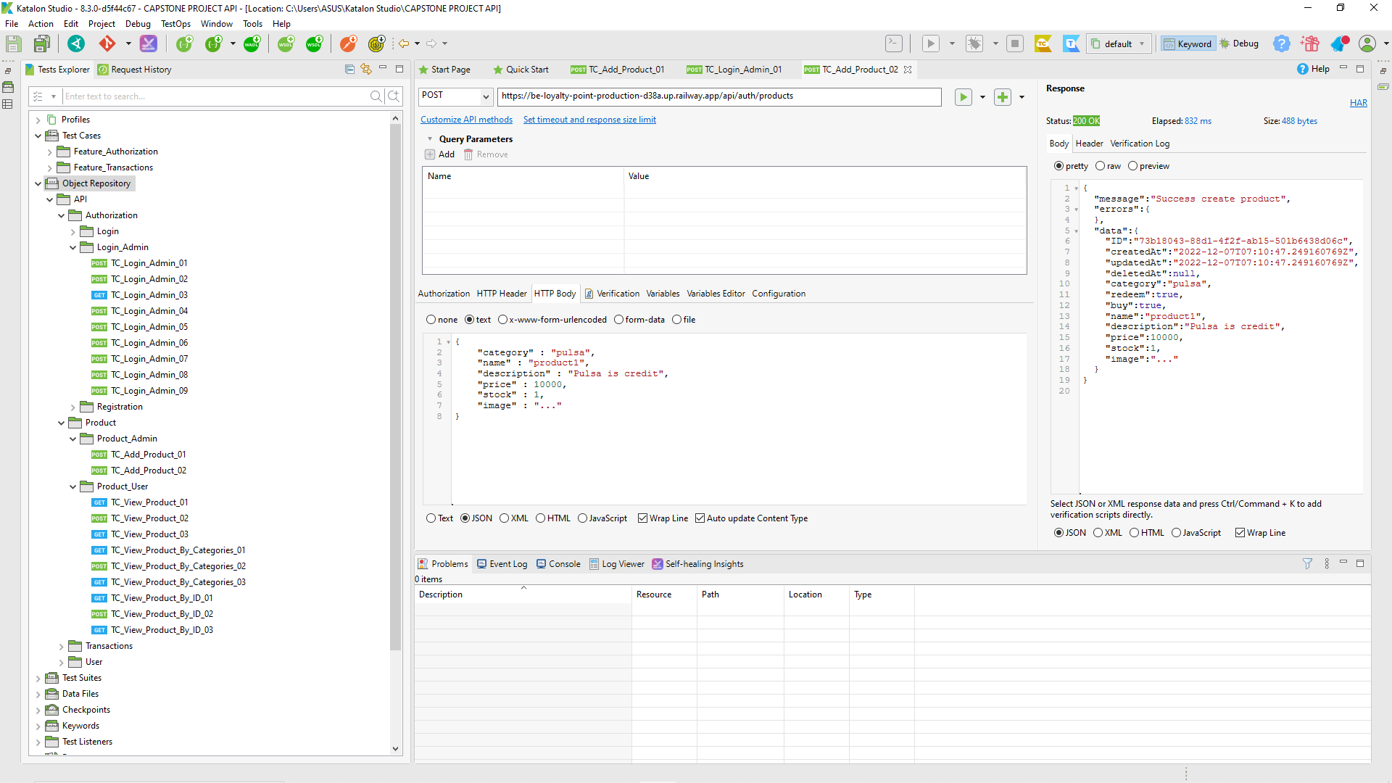

| Defect ID | DF014 |
| --- | --- |
| Tittle | Admin can add new product after login as admin without fill name |
| Test Cases ID | TC_Add_Product_04 |
| Reported Date | 11-Dec-2022 |
| Priority | High |
| Status | On Progress |
| Descriptions | When Admin can add new product after login as admin without fill name |
| Expected Result | - Response 400 Bad Request |
| Actual Result | - Response 200 |
| Report to | Back End |

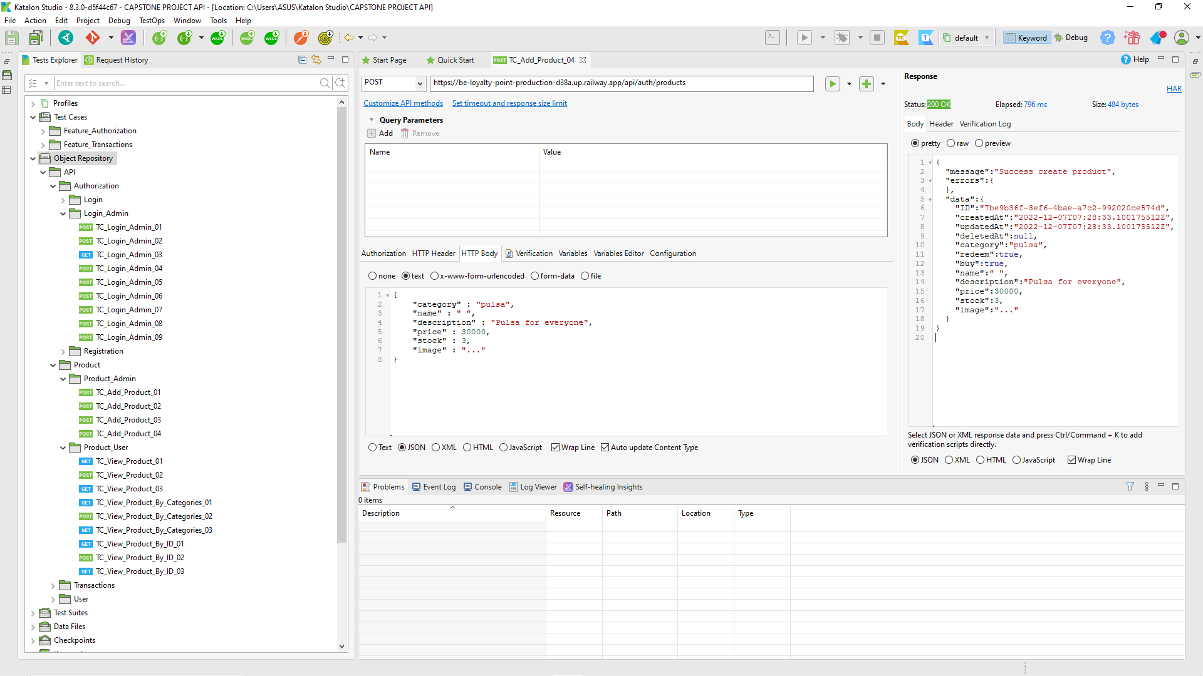

| Defect ID | DF015 |
| --- | --- |
| Tittle | Admin can add new product after login as admin without fill description |
| Test Cases ID | TC_Add_Product_05 |
| Reported Date | 11-Dec-2022 |
| Priority | High |
| Status | On Progress |
| Descriptions | When Admin can add new product after login as admin without fill description |
| Expected Result | - Response 400 Bad Request |
| Actual Result | - Response 200 |
| Report to | Back End |

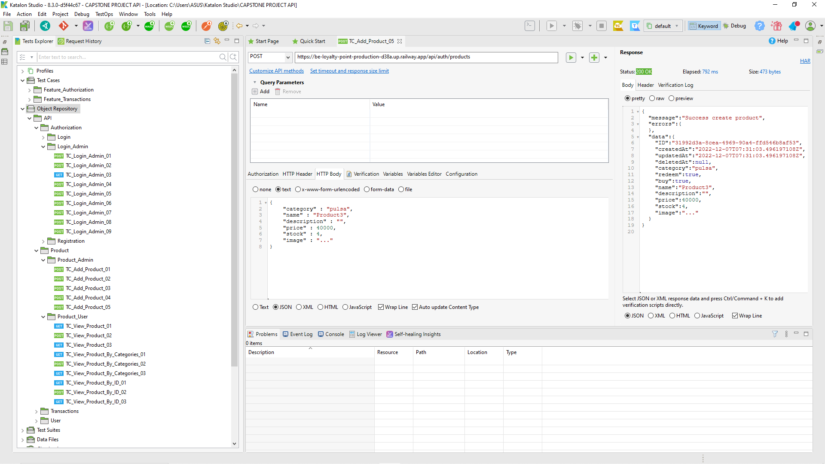

| Defect ID | DF016 |
| --- | --- |
| Tittle | Admin can add new product after login as admin with invalid stock |
| Test Cases ID | TC_Add_Product_09 |
| Reported Date | 11-Dec-2022 |
| Priority | High |
| Status | On Progress |
| Descriptions | When Admin can add new product after login as admin with invalid stock |
| Expected Result | - Response 400 Bad Request |
| Actual Result | - Response 200 |
| Report to | Back End |

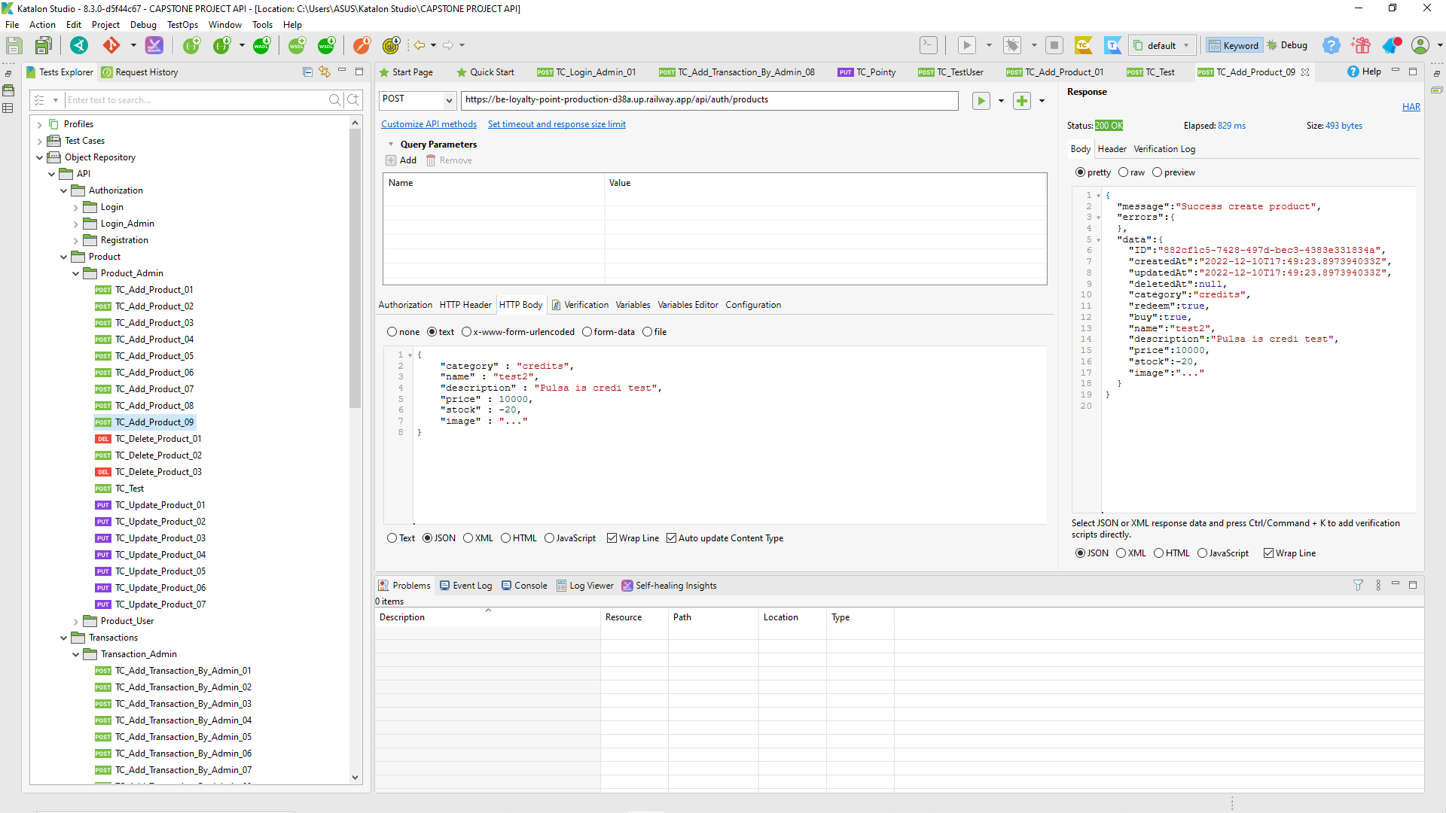

| Defect ID | DF017 |
| --- | --- |
| Tittle | Admin can add new product after login as admin with invalid price |
| Test Cases ID | TC_Add_Product_10 |
| Reported Date | 11-Dec-2022 |
| Priority | High |
| Status | On Progress |
| Descriptions | When Admin can add new product after login as admin with invalid price |
| Expected Result | - Response 400 Bad Request |
| Actual Result | - Response 200 |
| Report to | Back End |

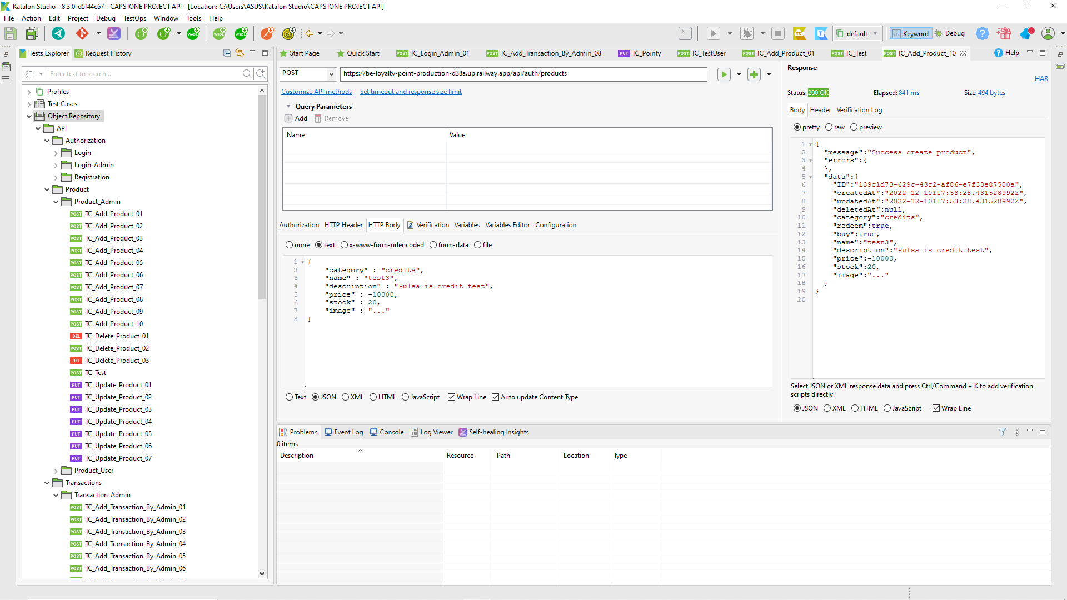

| Defect ID | DF018 |
| --- | --- |
| Tittle | Admin can update product after login as admin with same data |
| Test Cases ID | TC_Update_Product_02 |
| Reported Date | 11-Dec-2022 |
| Priority | High |
| Status | On Progress |
| Descriptions | When Admin can update product after login as admin with same data |
| Expected Result | - Response 400 Bad Request |
| Actual Result | - Response 200 |
| Report to | Back End |

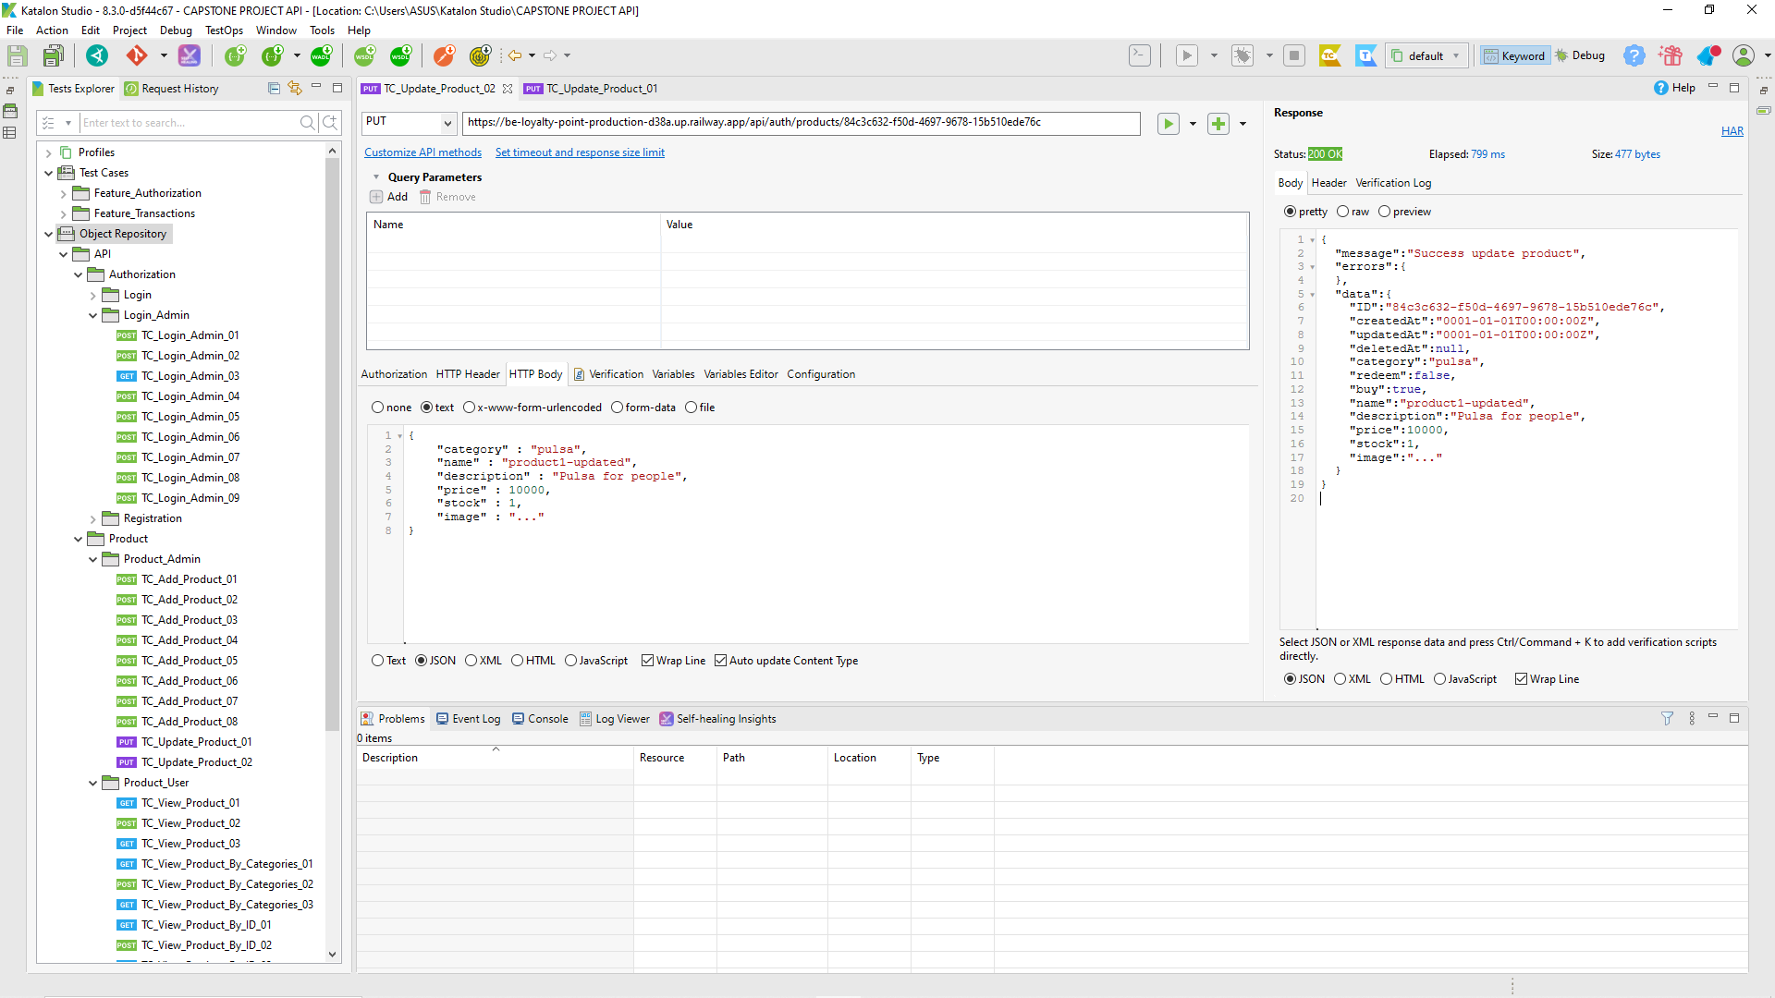

| Defect ID | DF019 |
| --- | --- |
| Tittle | Admin can update product after login as admin with same data |
| Test Cases ID | TC_Update_Product_02 |
| Reported Date | 11-Dec-2022 |
| Priority | High |
| Status | On Progress |
| Descriptions | When Admin can update product after login as admin with same data |
| Expected Result | - Response 400 Bad Request |
| Actual Result | - Response 200 |
| Report to | Back End |



| Defect ID | DF020 |
| --- | --- |
| Tittle | Admin can update product after login as admin without fill name |
| Test Cases ID | TC_Update_Product_04 |
| Reported Date | 11-Dec-2022 |
| Priority | High |
| Status | On Progress |
| Descriptions | When Admin can update product after login as admin without fill name |
| Expected Result | - Response 400 Bad Request |
| Actual Result | - Response 200 |
| Report to | Back End |

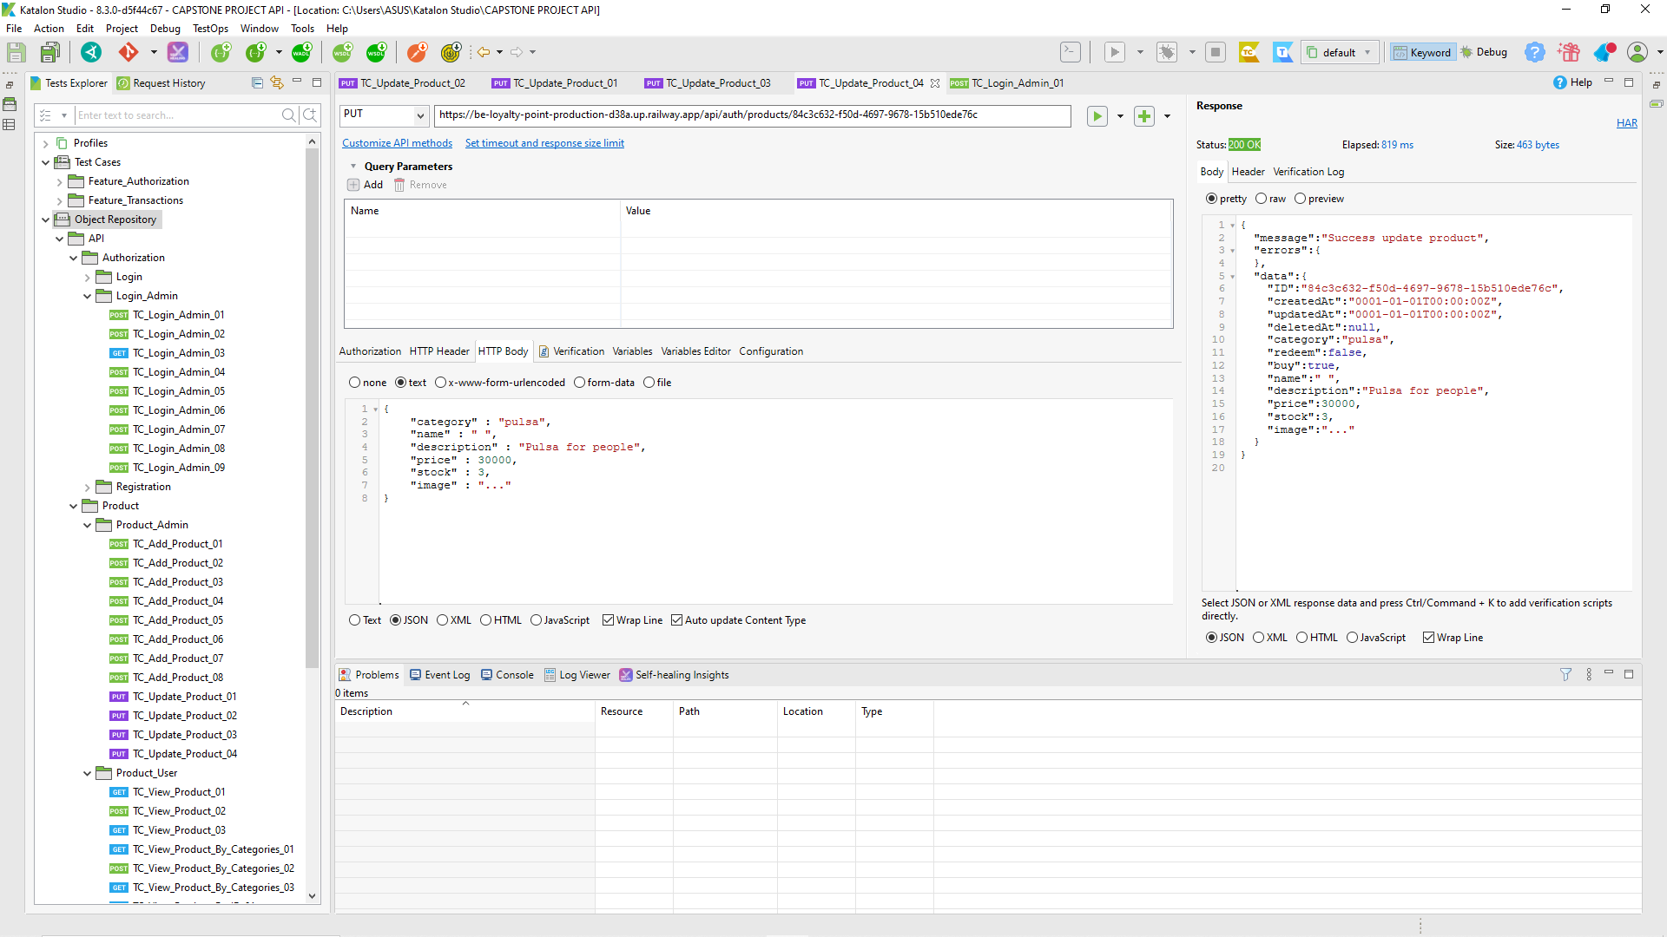

* User

| Defect ID | DF021 |
| --- | --- |
| Tittle | Admin can add new user after login as admin without fill password |
| Test Cases ID | TC_Add_User_05 |
| Reported Date | 11-Dec-2022 |
| Priority | High |
| Status | On Progress |
| Descriptions | When Admin can add new user after login as admin without fill password |
| Expected Result | - Response 400 Bad Request |
| Actual Result | - Response 200 |
| Report to | Back End |

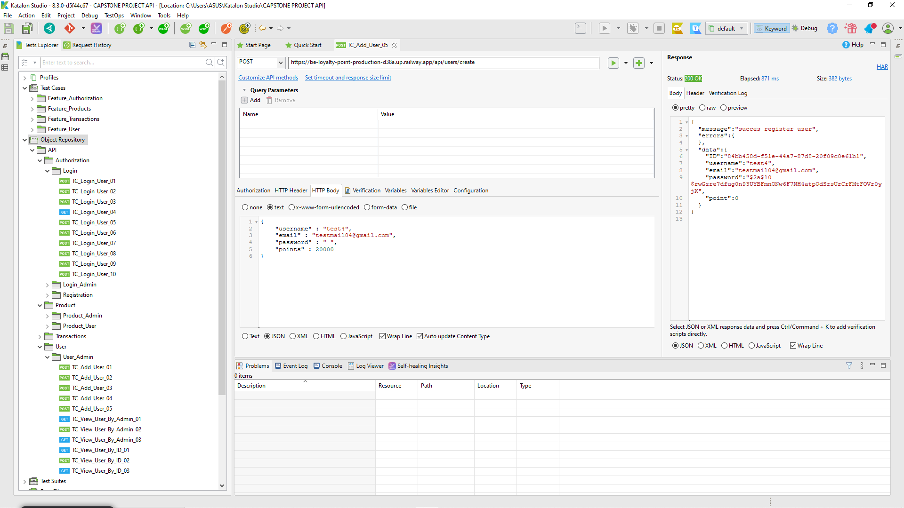

| Defect ID | DF022 |
| --- | --- |
| Tittle | Admin can update user after login as admin with same data |
| Test Cases ID | TC_Update_User_02 |
| Reported Date | 11-Dec-2022 |
| Priority | High |
| Status | On Progress |
| Descriptions | When Admin can update user after login as admin with same data |
| Expected Result | - Response 400 Bad Request |
| Actual Result | - Response 200 |
| Report to | Back End |

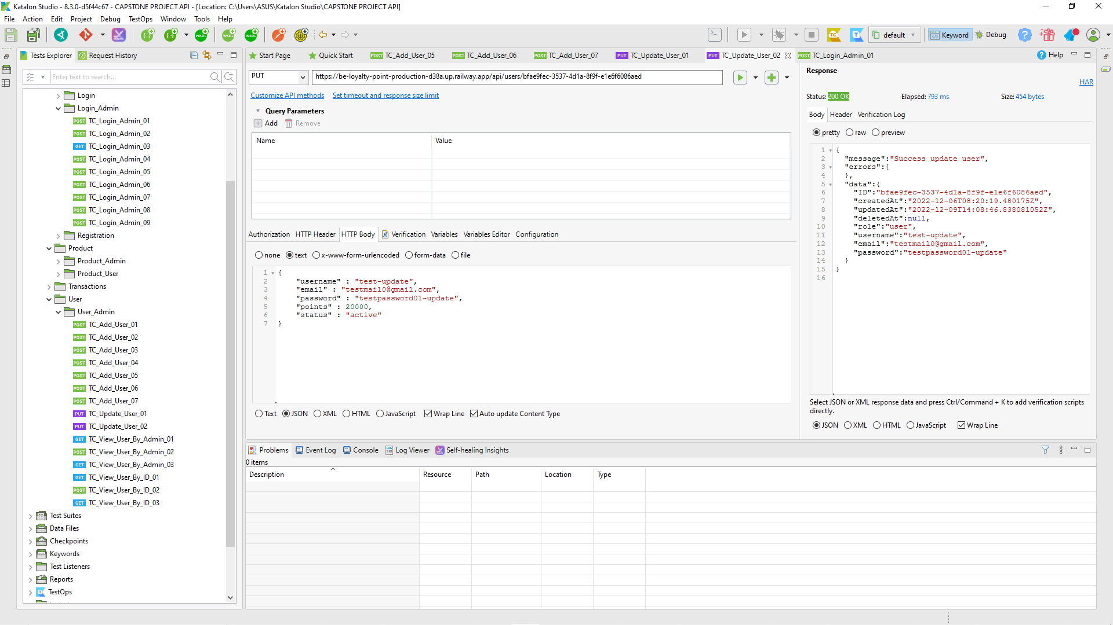

* Transaction

| Defect ID | DF023 |
| --- | --- |
| Tittle | Admin can add new transcations after login without fill identifier num data |
| Test Cases ID | TC_Add_Transaction_By_Admin_06 |
| Reported Date | 11-Dec-2022 |
| Priority | High |
| Status | On Progress |
| Descriptions | When Admin can add new transcations after login without fill identifier num data |
| Expected Result | - Response 400 Bad Request |
| Actual Result | - Response 200 |
| Report to | Back End |

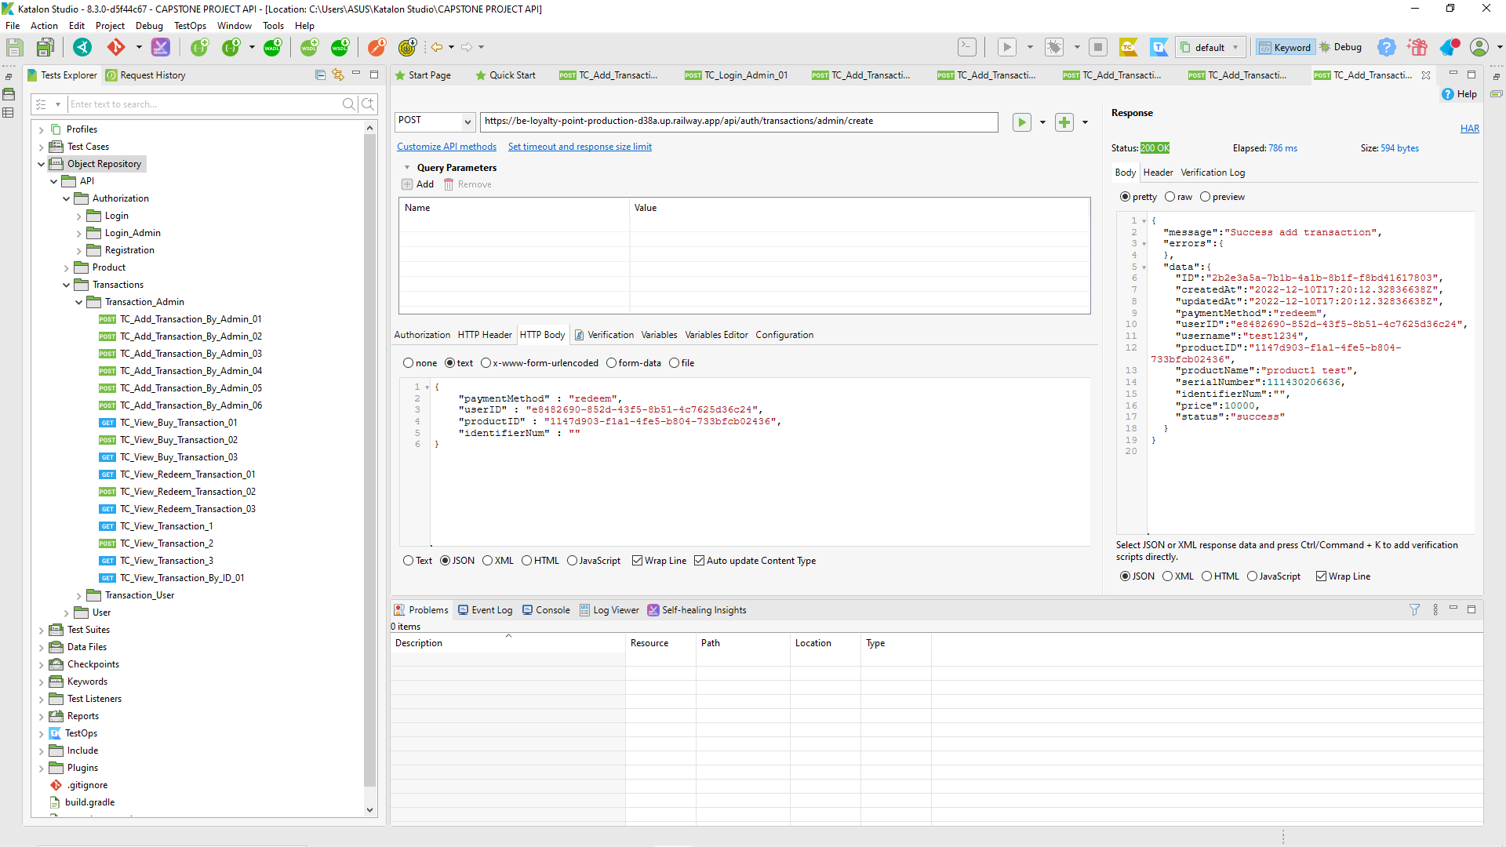

| Defect ID | DF024 |
| --- | --- |
| Tittle | Admin can add new transcations after login with wrong format identifier num |
| Test Cases ID | TC_Add_Transaction_By_Admin_07 |
| Reported Date | 11-Dec-2022 |
| Priority | High |
| Status | On Progress |
| Descriptions | When Admin can add new transcations after login with wrong format identifier num |
| Expected Result | - Response 400 Bad Request |
| Actual Result | - Response 200 |
| Report to | Back End |

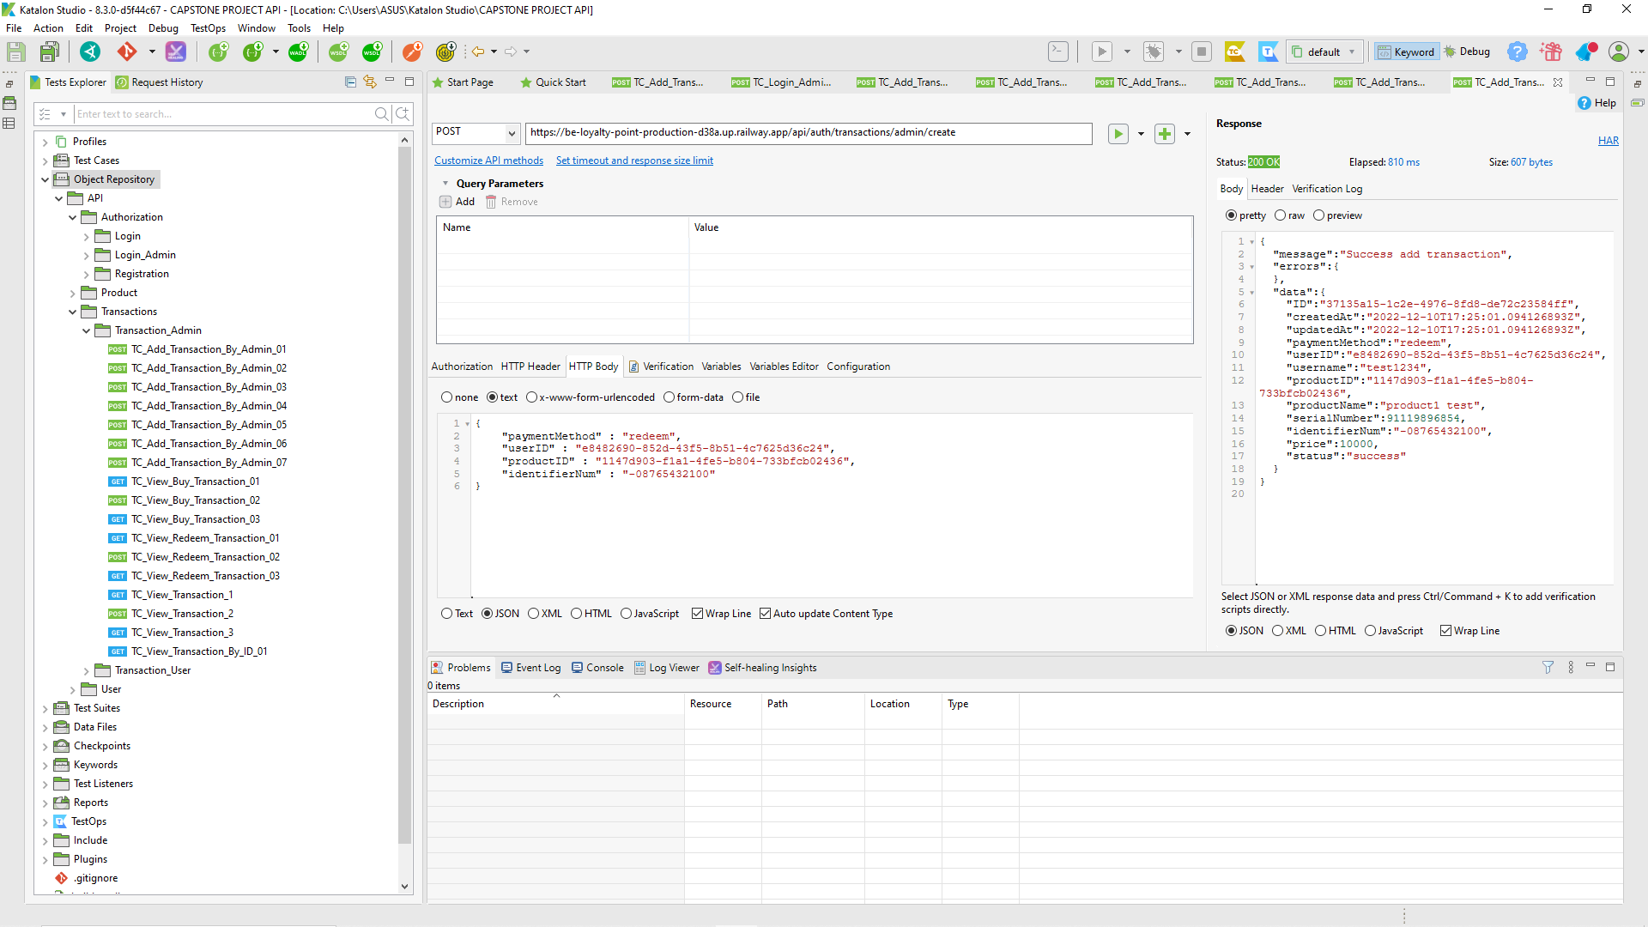

| Defect ID | DF024 |
| --- | --- |
| Tittle | Admin can add new transcations after login with wrong format identifier num min 11 number |
| Test Cases ID | TC_Add_Transaction_By_Admin_08 |
| Reported Date | 11-Dec-2022 |
| Priority | High |
| Status | On Progress |
| Descriptions | When Admin can add new transcations after login with wrong format identifier num min 11 number |
| Expected Result | - Response 400 Bad Request |
| Actual Result | - Response 200 |
| Report to | Back End |

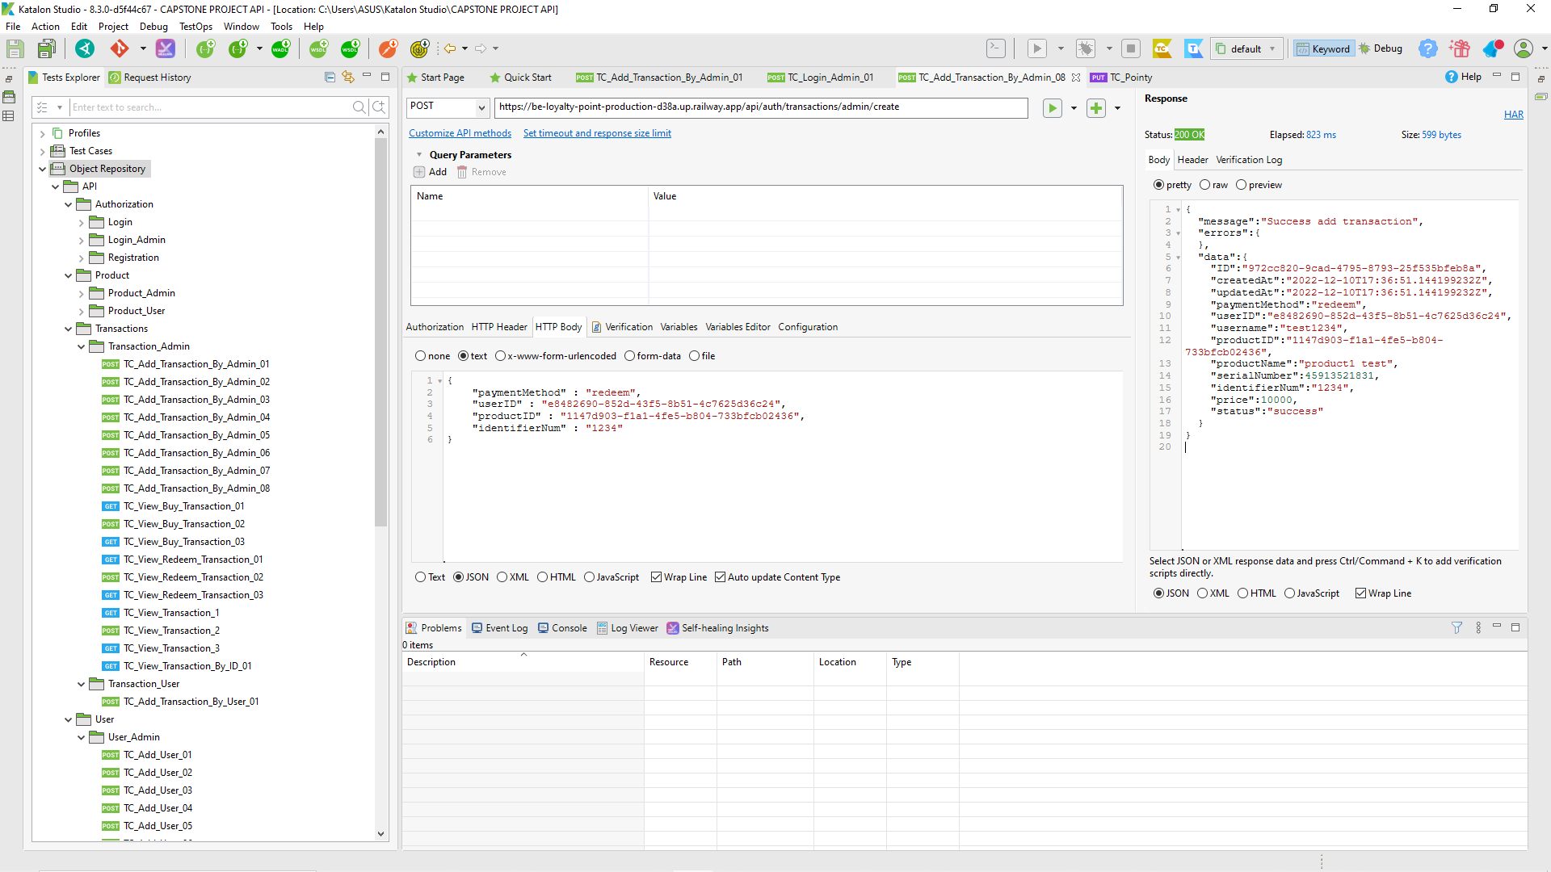

| Defect ID | DF025 |
| --- | --- |
| Tittle | Admin can add new transcations but minus price in server |
| Test Cases ID | TC_Add_Transaction_By_Admin_11 |
| Reported Date | 11-Dec-2022 |
| Priority | High |
| Status | On Progress |
| Descriptions | When Admin can add new transcations but minus price in server |
| Expected Result | - Response 400 Bad Request |
| Actual Result | - Response 200 |
| Report to | Back End |

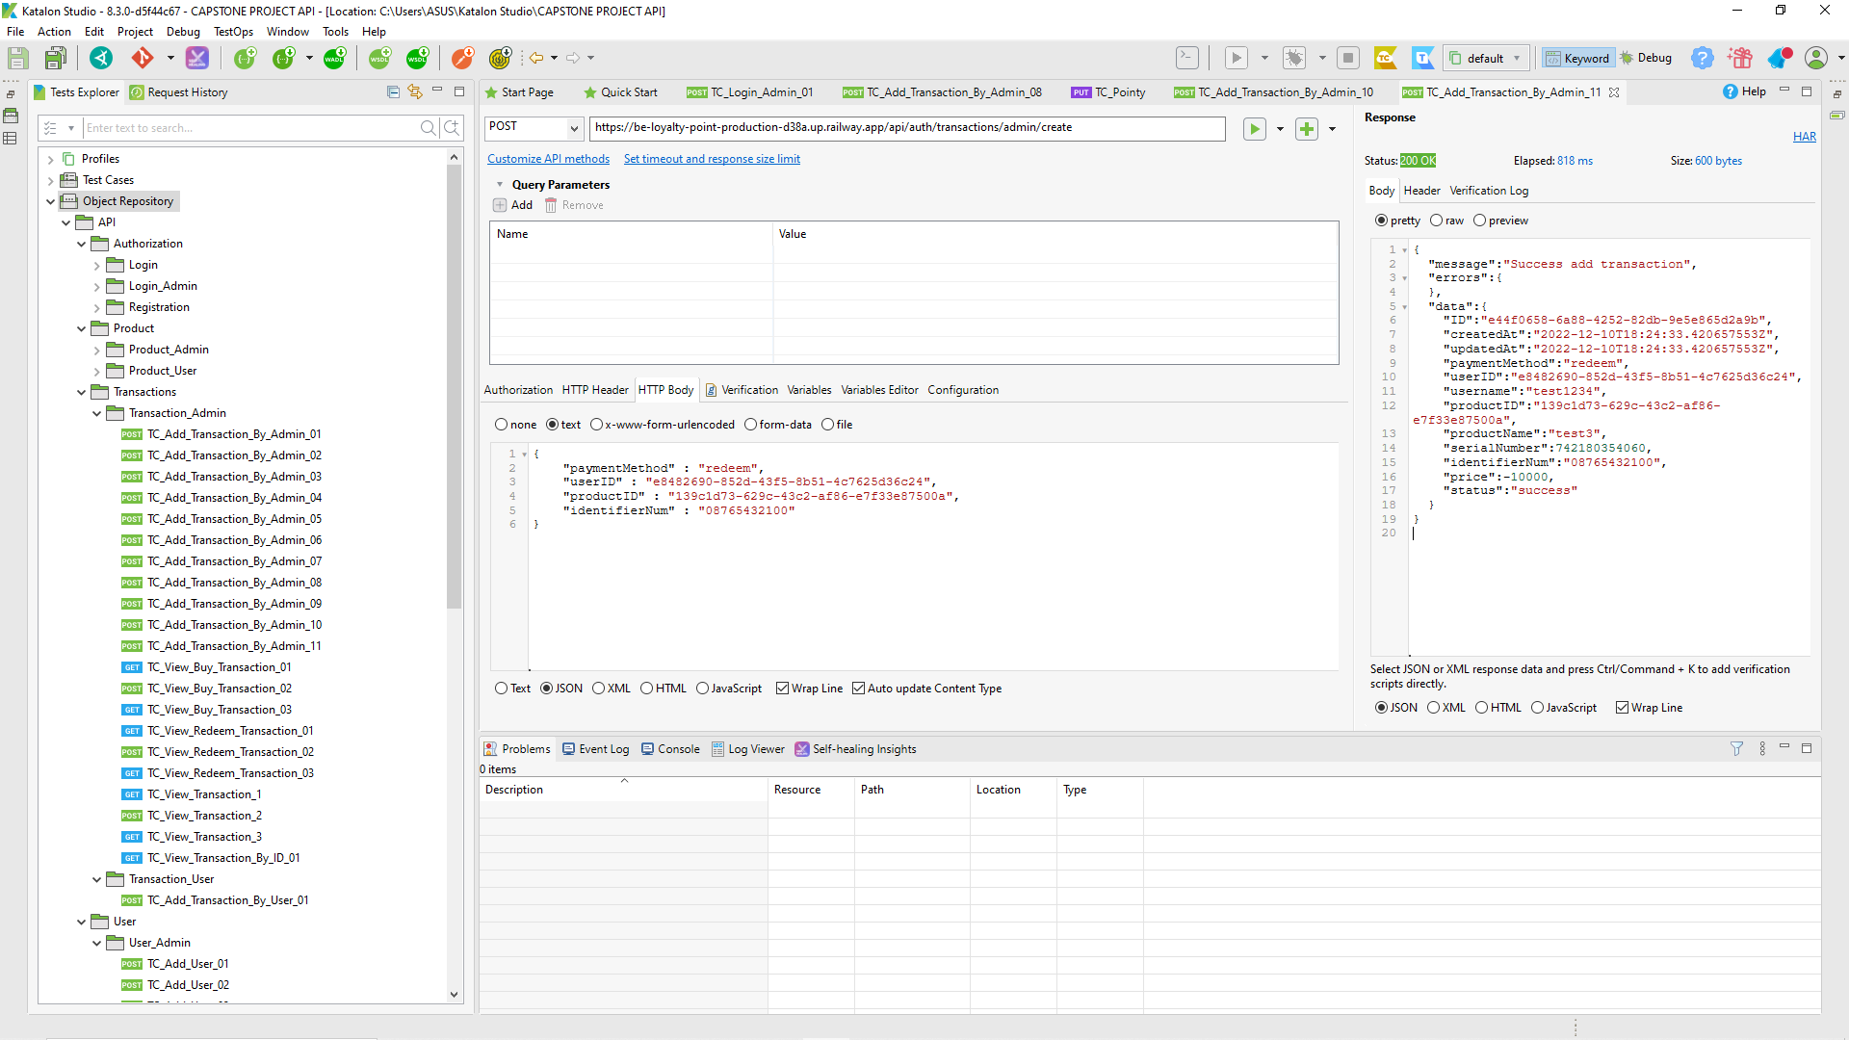

1. MOBLE

* Buy Product

1. Buy Credits

| Defect ID |  |
| --- | --- |
| Tittle | User buy credits with the valid number phone |
| Test Cases ID | TC_Buy Credits_01 |
| Reported Date | 9-Dec-2022 |
| Priority | High |
| Status | On Progress |
| Descriptions | After user choose the payment method |
| Expected Result | User directed to the gopay page |
| Actual Result | User cannot connect to gopay page |
| Report to | Flutter |

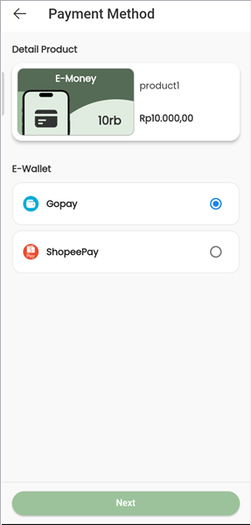

| Defect ID |  |
| --- | --- |
| Tittle | User buy credits with the invalid number phone |
| Test Cases ID | TC_Buy Credits_02 |
| Reported Date | 9-Dec-2022 |
| Priority | High |
| Status | On Progress |
| Descriptions | After user input invalid number phone |
| Expected Result | Error message phone number invalid |
| Actual Result | User directed to page payment method |
| Report to | Flutter |



1. Buy Data Quota

| Defect ID |  |
| --- | --- |
| Tittle | User buy data quota with the valid number phone |
| Test Cases ID | TC_Buy Data Quota_01 |
| Reported Date | 9-Dec-2022 |
| Priority | High |
| Status | On Progress |
| Descriptions | After user choose the payment method |
| Expected Result | User directed to the gopay page |
| Actual Result | User cannot connect to gopay page |
| Report to | Flutter |

| Defect ID |  |
| --- | --- |
| Tittle | User buy data quota with the invalid number phone |
| Test Cases ID | TC_Buy Credits_02 |
| Reported Date | 9-Dec-2022 |
| Priority | High |
| Status | On Progress |
| Descriptions | After user input invalid number phone |
| Expected Result | Error message phone number invalid |
| Actual Result | User directed to page payment method |
| Report to | Flutter |

1. Buy